Create a swap file case-1

* If you want to create a swap file on Linux. First we can add disk in os level as per our requirement.
* To check the lun weather the disk is added or not.

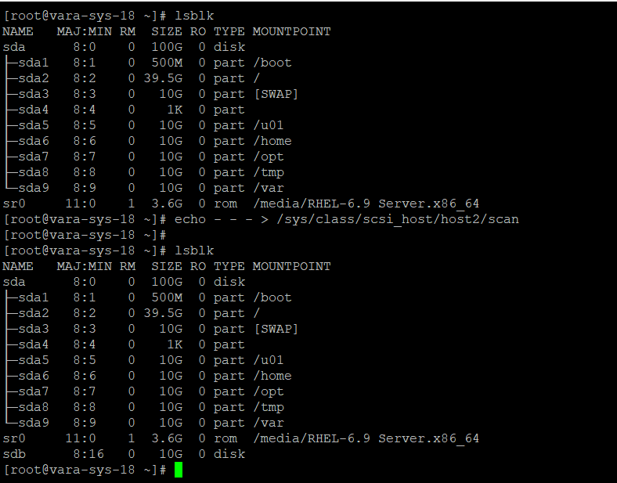

* To make the swap file system by using the command mkswap

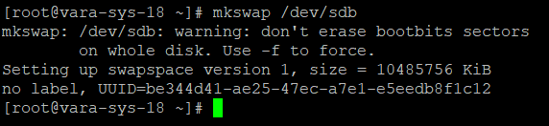

* After that to persistent the swap file across the reboot.

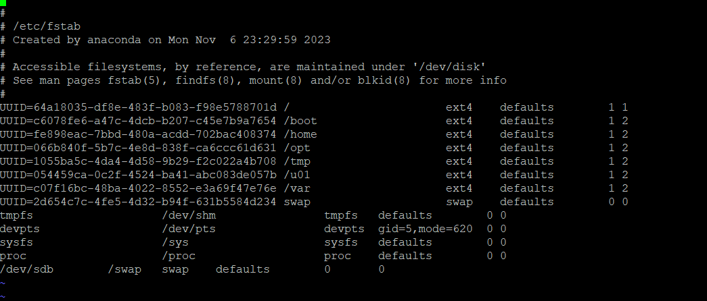

* To mount the swap file by using the command
* #Swapon /dev/sdb
* 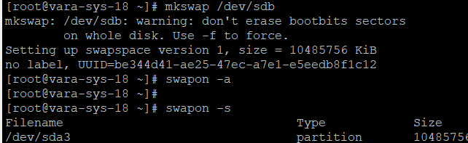
* To check the swap files by using the command
* #swapon -s

